***10 hours by 7/19/21***

How many hours ___?

Place ticket in Teen container

End Program Drawings

___

Hours

s

___

Hours

___

Hours

___

Hours

___

Hours

**Prize Drawing**

**Each Hour you read gives you a chance to win a prize. Write the number of hours you’ve read on a ticket. Increase your chance of winning a prize at the end by turning in hours each week.**



Wornstaff Memorial Public Library

740-747-2085

information@wornstafflibrary.com  
Subscribe to the newsletter

www.wornstafflibrary.com

Check out these APPS:   
COOL Libraries and LIBBY

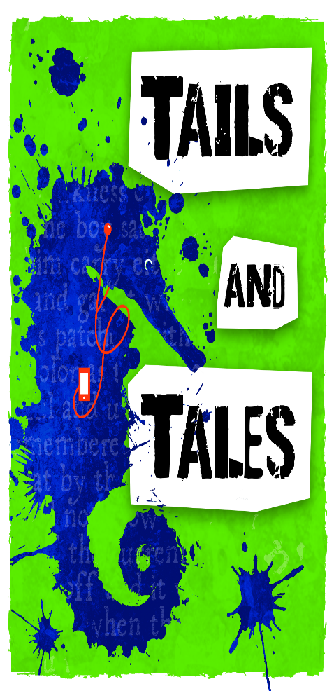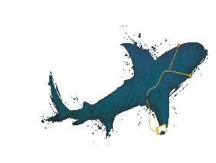

***10 hours by 7/19/21***

How many hours ___?

Place ticket in Teen container

End Program Drawings

___

Hours

s

___

Hours

___

Hours

___

Hours

___

Hours

**Prize Drawing**

**Each Hour you read gives you a chance to win a prize. Write the number of hours you’ve read on a ticket. Increase your chance of winning a prize at the end by turning in hours each week.**



Wornstaff Memorial Public Library

740-747-2085

information@wornstafflibrary.com  
Subscribe to the newsletter

www.wornstafflibrary.com

Check out these APPS:   
COOL Libraries and LIBBY



Name _____________

Phone_____________

Name _____________

Phone_____________

Name _____________

Phone_____________

Name _____________

Phone_____________

Name _____________

Phone_____________

Name _____________

Phone_____________

**Teens:**

**Turn your tickets in**

**today!**

**Don’t miss out!!!!**

**We want you to win a prize!**



Wornstaff Memorial Public Library

740-747-2085

information@wornstafflibrary.com

Subscribe to our Newsletter by going to www.wornstafflibrary.com

Check out these APPS:   
COOL Libraries and LIBBY

**Teen Prize Drawing**

**Each Hour you read gives you a chance to win a prize. Write the number of hours you’ve read on a ticket. Increase your chance of winning a prize at the end by turning in hours each week.**

Name _____________

Phone_____________

Name _____________

Phone_____________

Name _____________

Phone_____________

Name _____________

Phone_____________

Name _____________

Phone_____________

Name _____________

Phone_____________

**Teens:**

**Turn your tickets in**

**today!**

**Don’t miss out!!!!**

**We want you to win a prize!**



Wornstaff Memorial Public Library

740-747-2085

information@wornstafflibrary.com

Subscribe to our Newsletter by going to www.wornstafflibrary.com

Check out these APPS:   
COOL Libraries and LIBBY

**Teen Prize Drawing**

**Each Hour you read gives you a chance to win a prize. Write the number of hours you’ve read on a ticket. Increase your chance of winning a prize at the end by turning in hours each week.**